**Did we search all available conference calls?**

1. Did we download all available calls?

* We downloaded calls from 1 Jan 2001 – 7 Sep 2021.
* The number of calls downloaded is about the same as the number of calls shown on Thomson One.
* The number of *unique* calls downloaded is noticeably fewer than the number of calls downloaded. This suggests that the number of calls shown on Thomson One, and the number of calls downloaded are inflated by duplicates.
* I checked the duplicates found in search 2, and confirmed that the entries with the same report ID are indeed duplicates (i.e. they belong to the same firm, have the same date etc.), and are not actually different reports. This confirms that every report has a unique report ID.
* From a rough measure that includes duplicates, we downloaded very close to all of the available calls.
  + (548793 + 40235) - (548084 + 40154) = roughly 790 missing calls
  + (548084 + 40154) / (548793 + 40235) = 99.87% of calls shown on Thomson One downloaded

|  |  |  |  |
| --- | --- | --- | --- |
| **Date Range** | **Number of calls shown on Thomson One** | **Number of calls downloaded** | **Number of unique calls downloaded** |
| Search 1: 1 Jan 2001 - 5 Apr 2021 | 548793 | 548084 | 538619 |
| Search 2: 1 Oct 2020 to 7 Sep 2021 | 40235 | 40154 | 39754 |
| Total: 1 Jan 2001 – 7 Sep 2021 | 568805 | - | 558391 |

2. Did we search all the calls we downloaded?

* Unless there’s a mistake somewhere, we should have iterated through all downloaded calls.

**Screenshots of numbers shown on Thomson One (because the numbers may change over time)**

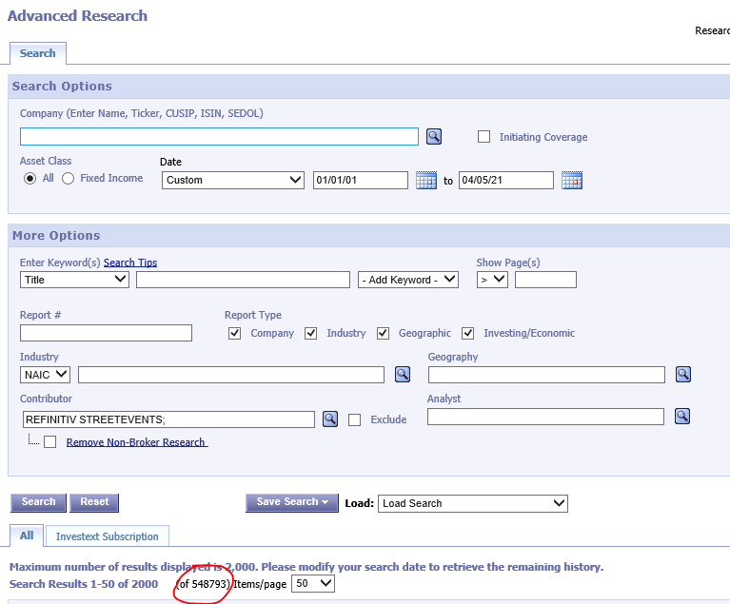

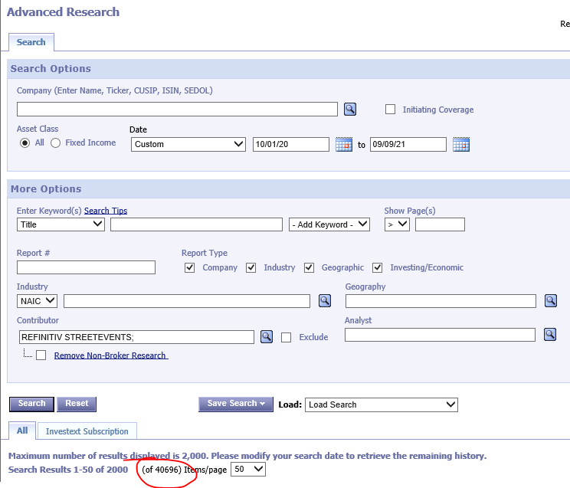

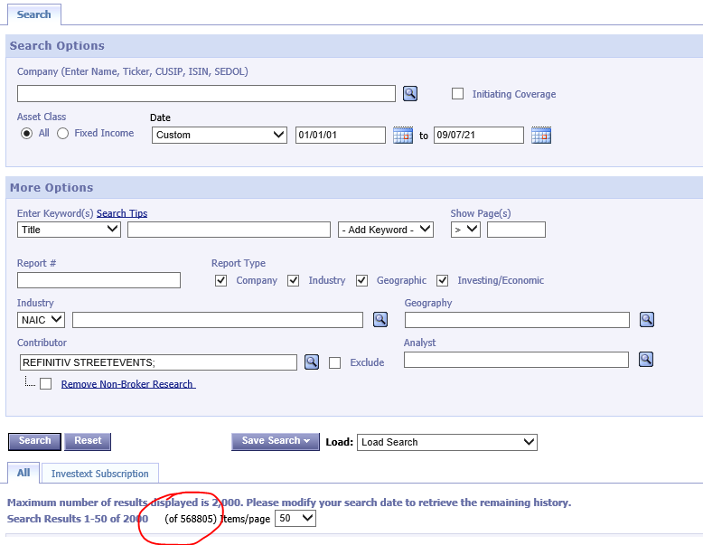

**Screenshot of some duplicate entries in Search 2**

